**Hidden Datasets**

Creation of Hidden Datasets

Hidden datasets are created like normal datasets only but the difference is there in their dataset_id. Hidden Datasets are named with an underscore in the beginning.

Example: _hidden123

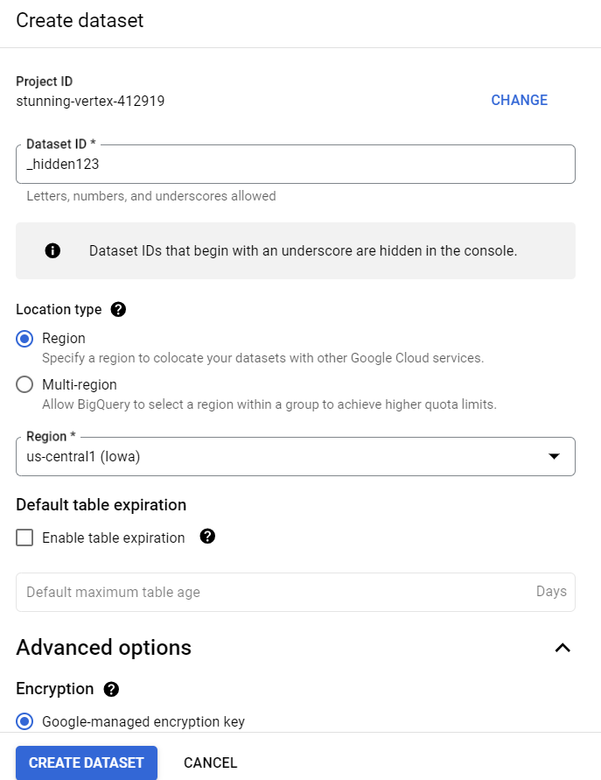

After creation of this dataset. Let’s see in explorer that whether this dataset is visible there or not.  
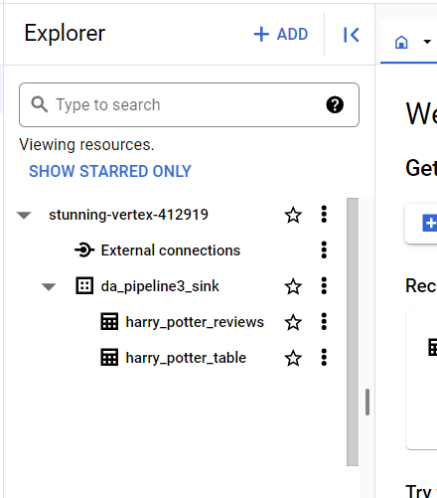

As we can clearly see that the dataset is not listed there.

Now let’s check the information_schema views.

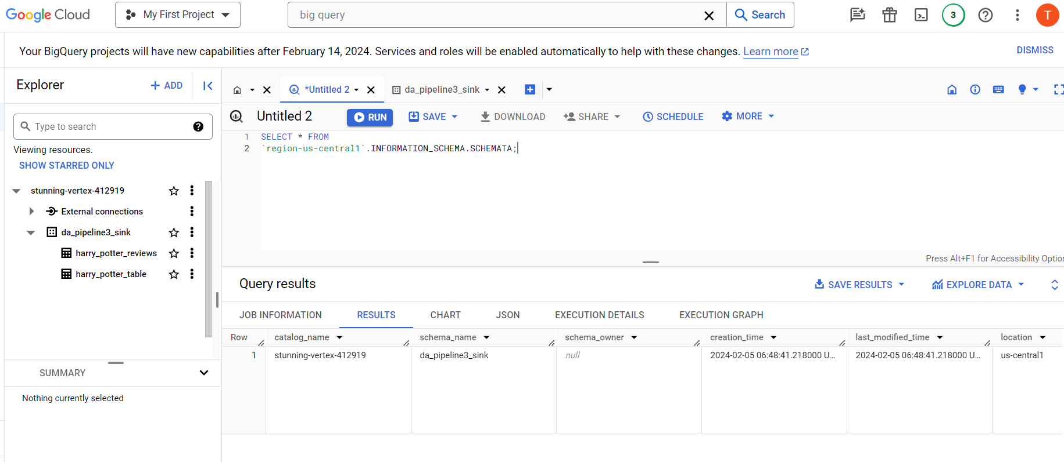

As we can see there is only one entry. That is the dataset for the current selected project which is in us-central1.

However, we can create tables in a hidden dataset if we know the name of the hidden dataset.

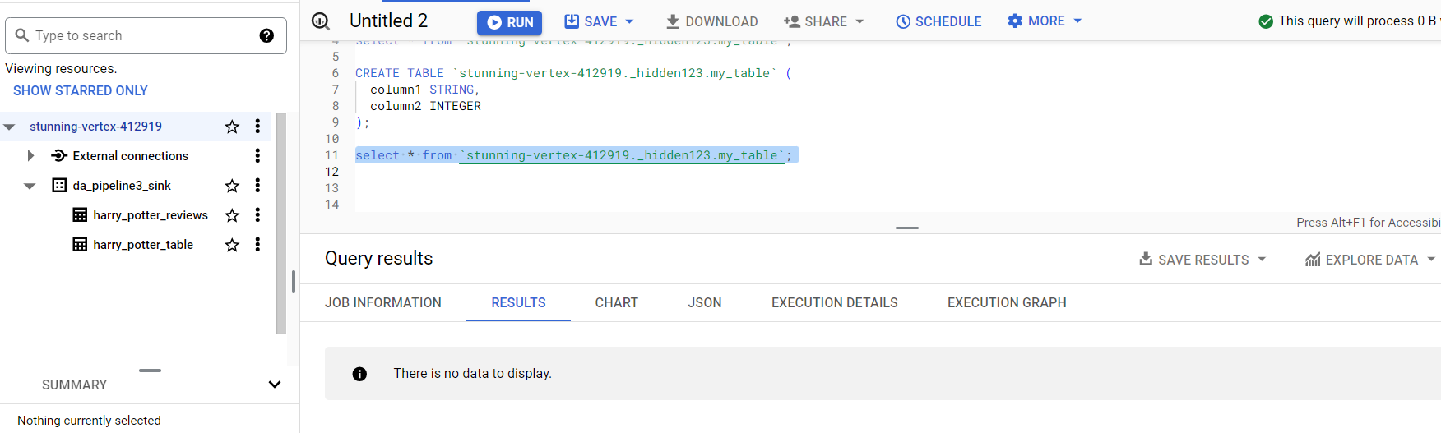

And we can also access and list these hidden datasets using bq commands in cloud shell or using API calls.

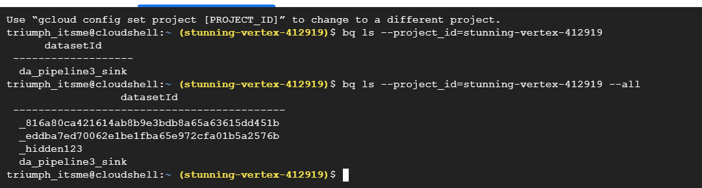

**Required Permissions:**

To see hidden datasets in Google BigQuery, a user must have the appropriate permissions set at either the project level or the dataset level. Additionally, the user needs the necessary permissions to list datasets in the Google Cloud project. Here are the required permissions:

**1. Project-Level Permissions:**

- BigQuery Data Viewer (roles/bigquery.dataViewer):

- This role grants users the ability to view datasets and their metadata within the project. It includes permissions to list datasets, view dataset properties, and access controls.

- BigQuery Metadata Viewer (roles/bigquery.metadataViewer):

- This role grants read-only access to metadata, including the ability to list datasets and view dataset properties and access controls.

Users assigned either of these roles at the project level should be able to see all datasets within the project, including hidden datasets.

**2. Dataset-Level Permissions:**

- BigQuery Data Viewer (roles/bigquery.dataViewer):

- Users assigned this role on specific datasets can view the datasets' metadata, including hidden datasets.

- BigQuery Metadata Viewer (roles/bigquery.metadataViewer):

- Similar to the project-level role, this role grants read-only access to metadata at the dataset level, allowing users to see hidden datasets if they have been granted access to them.

Ensure that users are assigned one of these roles at the appropriate level (project or dataset) to view hidden datasets. Additionally, users need the `bigquery.datasets.get` and `bigquery.datasets.list` permissions, which are included in the roles mentioned above, to list datasets.

It's worth noting that if a user is unable to see hidden datasets even with the appropriate permissions, there might be other factors at play, such as organization policies or IAM conditions that restrict visibility. In such cases, further investigation might be necessary to identify the root cause of the issue.

**Use Cases:**

Hidden datasets in Google BigQuery can serve various use cases depending on the specific needs of an organization. Here are some common scenarios where hidden datasets might be useful:

**1. Sensitive Data Storage:**

- Organizations often have sensitive or confidential data that should only be accessed by authorized users. Hidden datasets can be used to store this type of data, limiting visibility to only those users who have explicit permissions to access it.

**2. Internal Workflows:**

- Sometimes, datasets are used for internal processes or workflows that don't need to be exposed to all users. Hidden datasets can be used to store intermediate or temporary data used in these processes without cluttering the dataset list for all users.

**3. Development and Testing:**

- During development or testing phases, teams might create datasets for experimentation or staging purposes. These datasets may not need to be visible to all users until they are ready for production use.

**4. Partitioned Data Storage:**

- In some cases, datasets might be partitioned based on different criteria (e.g., time, region). Hidden datasets can be used to store partitions that are not currently active or relevant, keeping the dataset list organized and manageable.

**5. Archival and Backup:**

- Datasets that are no longer actively used but need to be retained for archival or backup purposes can be hidden to prevent accidental modifications or queries. This helps ensure data integrity and compliance with retention policies.

**6. Internal Data Sharing**:

- In organizations with complex data-sharing requirements, hidden datasets can be used to control access to specific datasets based on business needs or project requirements. This allows for fine-grained access control while maintaining data privacy and security.

**7. Third-party Integrations:**

- Sometimes, third-party services or applications require access to certain datasets for integration purposes. Hidden datasets can be shared with these services without cluttering the dataset list for other users.

Overall, hidden datasets provide flexibility and control over data access and management in Google BigQuery, allowing organizations to tailor their data storage and sharing strategies to meet their specific requirements and compliance standards.